Assignment 6 – Savitha Balarajan

1.      Categorize products by stock status(Display product_name, a new column stock_status whose values are based on below condition.units_in_stock = 0  is 'Out of Stock, units_in_stock < 20  is 'Low Stock')

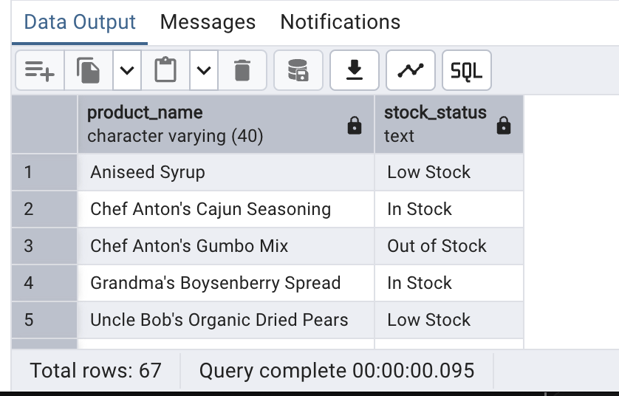

2.      Find All Products in Beverages Category

(Subquery, Display product_name,unitprice)

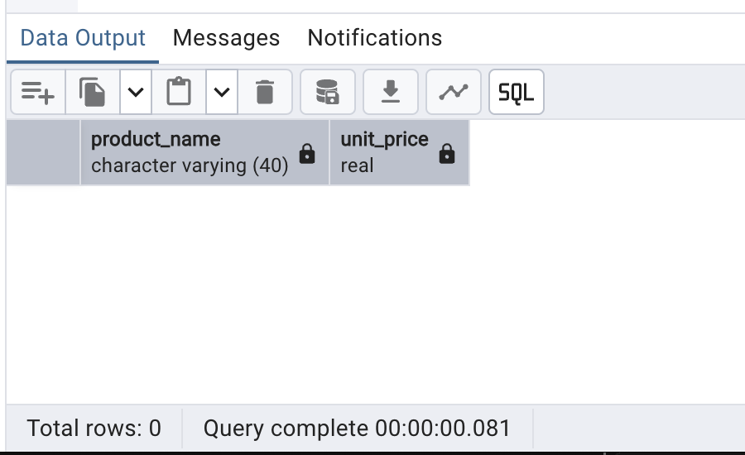

3.      Find Orders by Employee with Most Sales

(Display order_id,   order_date,  freight, employee_id.

Employee with Most Sales=Get the total no.of of orders for each employee then order by DESC and limit 1. Use Subquery)

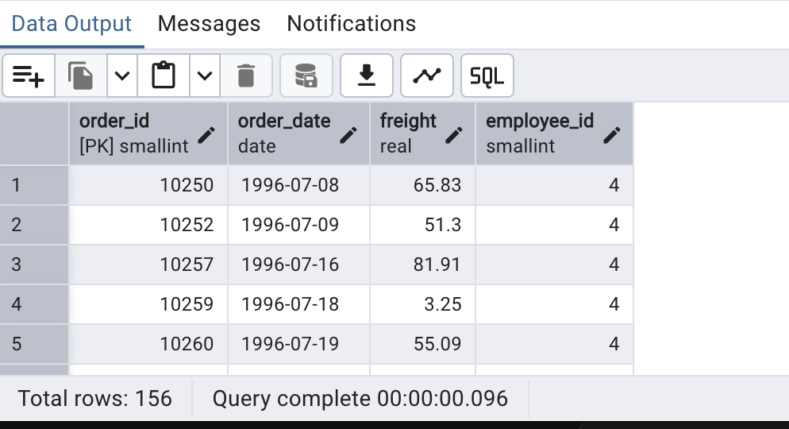

4.      Find orders  where for country!= ‘USA’ with freight costs higher than any order from USA. (Subquery, Try with ANY, ALL operators)

